RefWatch - Arsenal v Newcastle United - (Sunday 07/11/2010)
By DogFace
- Referee: Mike Dean
- Assistant 1: Simon Beck
- Assistant 2: Simon Long
- 4th Official: Peter Walton
This RefWatch is a tough one for me – how do I, as an Arsenal fan, possibly write up an article on Mike Dean in an unbiased manner without foaming at the mouth, shouting at the kids, kicking the dog and stamping on my laptop until the keys pop off? My feelings about Dean sum up a lot about what I think is wrong with English refereeing at the highest (sic) levels. Let’s just say that IF the PGMOB were a Masonic lodge with criminal tendencies... Dean would be at the right hand of his worshipful master [Riley].
I mean – where exactly does one start? Shall we check out his profile... oh go on then:
- Full name: Michael Leslie Dean
- Date of birth: 2 June 1968 (1968-06-02) (age 42)
- Place of birth: Wirral, Merseyside, England
- Favourite Colour: Red[knapp]
Ho, ho – ‘Leslie’ – and there I go with the favourite colour bit again... of course, I jest – but I can pull out a few interesting figures relating to that should we face a team managed by ‘Onest ‘Arry with Dean at the whistle – but that is not relevant to our game, so I’ll save it. I could had just have easily said ‘white’ was his favourite colour given Dean’s record with sending offs – I think it was the 2008/2009 season where, excluding Richard Dunne (who he seems to have some sort of grudge against anyway), he sent off only black players.
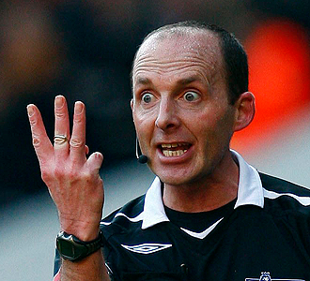
When I run out of fingers I might give you a yellow.
Of course this could all be coincidence - but it’s fair to say that, when it comes to consistency across the seasons, Dean likes to dish out the cards Arsenal’s way, and during last season [2009/2010] we came joint top (with Stoke) of the Mike Dean yellow card table – averaging 3 yellow cards per match (12 yellow cards in 4 matches); this despite Arsenal also coming top of the Premier League Fair Play table in that season. We also got zero penalties (for) and two against... so either Dean can’t control the game when we play or he just does *something* to make our players really very angry!?
Mike Dean is not, surprisingly, without his share of controversy – in fact there is so much of it in terms of random match decisions that I could fill a book... or at least a booklet with a small type face - so let’s focus on a few edited highlights:
In 2005 Mike Dean was banned for a few months due to his invalid links to an online betting site called Arbitros. Dean, or should I say ‘Arbitros’ offered gambling tips to happy punters and/or shares in a syndicate... no conflict of interest to be seen in that business venture obviously – I wonder if there were any ‘links’ to bookmakers [on the site]?
In the match against Harry Redknapp’s Tottenham (08/02/2009) Dean disallowed a goal by Emanuel Eboué for no apparent reason and consequently booked him for asking for an explanation. Eboué then saw a second yellow for asking Dean whether he should wait for the whistle before a free kick was taken (see ‘being uppity’) – this I found particularly harsh as Eboué’s relationship with the fanbase was at a fragile stage at this time.
During the 2009/2010 season, Dean took charge of the EPL ‘title decider’ (one suspects it was already decided before then though) between Manchester United and Chelsea at Old Trafford 03/04/2010 – Dean went on to mug the Red Devils by turning down 3 penalties and awarding a ‘clearly offside’ goal for Drogba. Dean was demoted after this for a game (and to provide a reassuring headline in the Daily Mail for the masses).
On the same ground (29/08/2009) Dean not only tilted the game in Manchester United’s favour, via a few bad calls, denying two clear penalties and throwing cards at Arsenal players like a croupier on crack; but he then proceeded to send Arsené Wenger to the stands for kicking a water bottle in frustration at yet another dubious offside call.
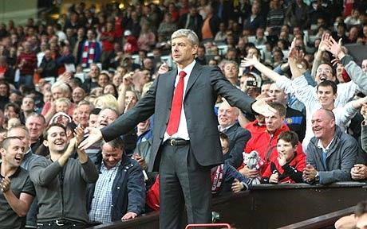
For your sins Mr. Dean... you know not what you do.
Of course Dean blamed it all on Lee Probert, and he went on gardening leave for a bit, while Mikey boy flew under the radar at mach 10, got the Sky games and continued to meddle in the title race. We received six yellow cards in this game; Manchester United got two (or three?) yellows despite committing more fouls in a match than I have ever seen ever (Manchester United got their cards in the latter stages, to even things up a bit, for two Man-U players in the same challenge on Diaby). To add insult to injury time; Arsenal were subsequently charged by the FA for ‘failing to control their players’ and ordered to pay a fine.
The big one for me though – and this is still a painful and poignant memory in my life, not only as a fan but as a member of our species - was when Arsenal played Birmingham at St. Andrews on the 23/02/2008. This match was the making of the ‘DogFace’ blog persona... until this moment I was in denial about the state of English football – after this match I made it my mission to find out as much as I could – it was the egg from whence I hatched and Dean became the Vader to my Skywalker. We would have won the 2007/2008 season, by the way, on the 19/04/2008 against Reading at The Emirates had we not had the unfeasibly unlikely run of bad calls against us... yet the apologist media just shrugged their shoulders and proclaimed we imploded through our lack of experience and a petulant captain. The self harmers, from their cosy arm chairs, agreed and blamed Wenger’s for his stubbornness.
I disagreed with them all.
Let me take you back to that game... Dean was ‘letting the game flow’ and giving full ‘home advantage’, in the tackle, to Birmingham. This without question led to the tackle on Eduardo from the ‘gentle giant’ Martin Taylor (not that type of lad) that snuffed out one of the brightest rising stars in the league at that time – Eduardo was never the same after that day. The media wrung their grubby little racist hands over this, pointed out that Eduardo was a turncoat Brazilian (not Croatian) and duly apologised for Martin before, and at the first opportunity, destroying any chance Eduardo might have as a comeback by labelling him ‘a cheat’. More column inches were given over to Eduardo’s ‘dive’ in a match that was already won than there were to Martin Taylor’s tackle – some sort of repressed guilt complex there methinks?
Anyway - Mike Dean decided that stopping the game was not on the cards despite (or because) of the distressed and ashen faces of the Arsenal team in response to their friend and colleague’s half severed foot... and, coincidently, there was an awful lot of money on Arsenal that day. The game went to 1-2 to Arsenal (Birmingham having scored from a dubious McFadden free kick) and in the extra, extra, last few finally final seconds of added on added on time - Gael Clichy cleanly took the ball in the penalty area in a 50/50 with McFadden. Mike ‘title decider’ Dean, giddy with joy and a spring in his step, gave a penalty against us and Mc Fadden scored making it 2-2 and that signalled the end of our season.

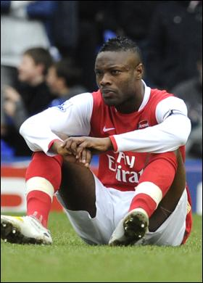
I know how you felt William – for I felt it too.
Anyway... enough of all that – more therapy for me than information for you so onto the data, as you can see we have an ‘ok’ home record with Dean (having not ever lost) although we are sliding into draws of late:
Arsenal Home under Mike Dean
Season | Competition | Home Win | Draw | Away Win
2000/2001 | English Premier | 2 | 0 | 0
2002/2003 | English Premier | 2 | 0 | 0
2003/2004 | English FA Cup | 1 | 0 | 0
2003/2004 | English Premier | 1 | 0 | 0
2004/2005 | English Premier | 1 | 0 | 0
2004/2005 | FA Community Shield | 1 | 0 | 0
2005/2006 | English Premier | 1 | 0 | 0
2006/2007 | English FA Cup | 0 | 1 | 0
2007/2008 | English League Cup | 0 | 1 | 0
2009/2010 | English Premier | 0 | 1 | 0

Our away record is not so ‘ok’:
Arsenal Away under Mike Dean
Season | Competition | Home Win | Draw | Away Win
2000/2001 | English Premier | 0 | 0 | 1
2003/2004 | English Premier | 0 | 0 | 2
2004/2005 | English Premier | 0 | 1 | 0
2005/2006 | English FA Cup | 1 | 0 | 0
2005/2006 | English Premier | 0 | 1 | 0
2006/2007 | English Premier | 1 | 1 | 1
2007/2008 | English League Cup | 0 | 0 | 1
2007/2008 | English Premier | 0 | 2 | 0
2008/2009 | English Premier | 0 | 2 | 2
2009/2010 | English Premier | 2 | 1 | 0
2010/2011 | English Premier | 1 | 0 | 0

Again - you can see, there is a distinct slide, of late, towards the negative.
So what can we expect this weekend from his worshipful randomiser? Song carded out of the challenge early on? A physical game? A sending off? Or perhaps a complete about turn and a romping win (the last two times we played Newcastle at home under Dean we scored 6 goals without answer).
So, in conclusion, I dunno – your guess is as good as mine... so sorry if I wasted your time – but expect something controversial!
As fans we need to keep the pressure on and shout something ‘Leslie’ at him for every bad call - and don’t be afraid to give the lino some stick for the same... his name is Simon by the way.
And – most importantly - as a fan - never, under ANY circumstances EVER put your ‘hard earned’ on your team to win anything ever – when we play, the mug money weighs so heavy on our backs.

